

**BHASKARACHARYA COLLEGE OF APPLIED SCIENCES , DU**

DATABASE MANAGEMENT SYSTEM PRACTICAL ASSIGNMENT

NAME :- DEEPAK KUMAR

ROLL NO. :- 2002019

SUBMITTED TO :-

MR. JAYANT SIR

Create the following database schema EMP-DEPT with all specified constraints and use it to answer the given queries.

EMPLOYEE Schema

Field Type NULL KEY DEFAULT

Eno Char(3) NO PRI NIL

Ename Varchar(50) NO NIL

Job_type Varchar(50) NO NIL

SupervisonENO Char(3) Yes FK NILHire_date Date NO NIL

Dno Integer YES FK NIL

Commission Decimal(10,2) YES NIL

Salary Decimal(7,2) NO NIL

**:::RESULT:::**

CREATE TABLE EMPLOYEE (

Eno CHAR(3) NOT NULL PRIMARY KEY,

ENAME VARCHAR(50) NOT NULL,

Job_Type VARCHAR(50) NOT NULL,

SupervisionENO CHAR(3),

Hire_date DATE NOT NULL,

Dno INTEGER,

Commision DECIMAL(10 , 2 ),

Salary DECIMAL(10 , 2 ) NOT NULL,

foreign key (Dno) references DEPARTEMENT(Dno),

foreign key (SupervisionENO) references EMPLOYEE(Eno)

);

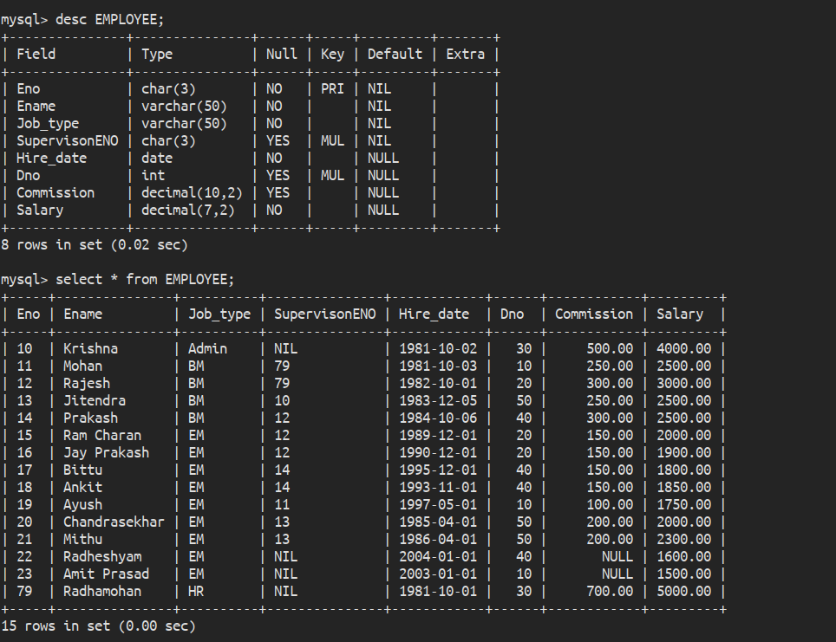

DEPARTMENT Schema

Dno Integer No PRI NULL

Dname Varchar(50) Yes NULL

Location Varchar(50) Yes New Delhi

**:::RESULT:::**

CREATE TABLE DEPARTEMENT (

Dno INTEGER NOT NULL PRIMARY KEY,

Dname VARCHAR(50),

Location VARCHAR(50) DEFAULT 'New Delhi'

);

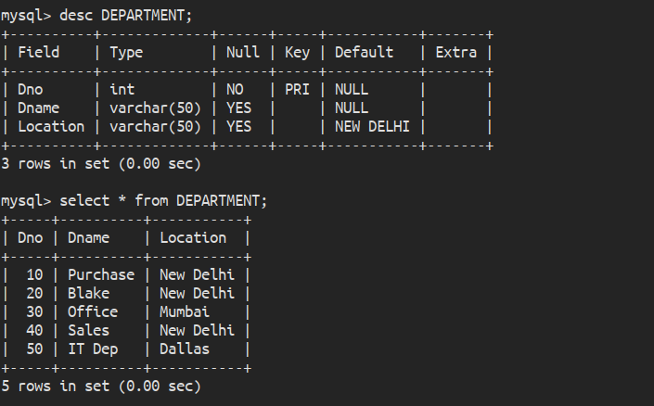

**:::QUERY-1:::**

Query to display Employee Name, Job, Hire Date, Employee Number; for each employee with the Employee Number appearing first.

**:::RESULT:::**

select Eno "Employee Number",Ename "Employee Name", Job_type "Job", Hire_date "Hire Date" from EMPLOYEE;

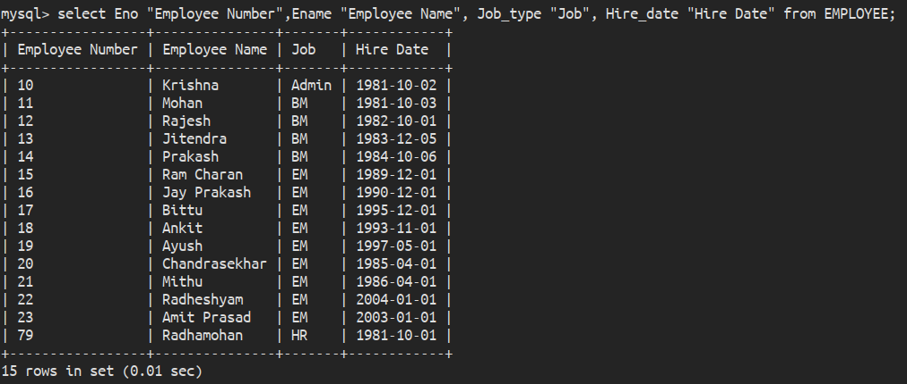

**:::QUERY-2:::**

Query to display unique Jobs from the Employee Table.

**:::RESULT:::**

select distinct Job_type "Unique Job" from EMPLOYEE;

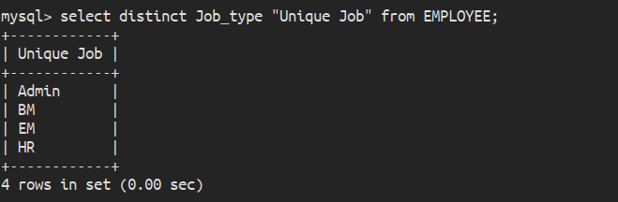

**:::QUERY-3:::**

Query to display the Employee Name concatenated by a Job separated by a comma.

**:::RESULT:::**

select concat(Ename,", ",Job_type) "Employee Name, Job" from EMPLOYEE;

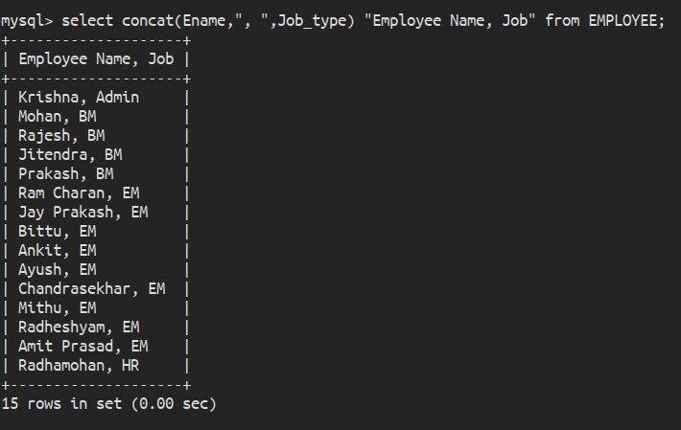

**:::QUERY-4:::**

Query to display all the data from the Employee Table. Separate each Column by a comma and name the said column as THE_OUTPUT.

**:::RESULT:::**

select concat(Eno,", ",Ename,", ",Job_type,", ",SupervisonENO,", ",Hire_date,", ",Dno,", ",Commission,", ",Salary) "THE_OUTPUT" from EMPLOYEE;

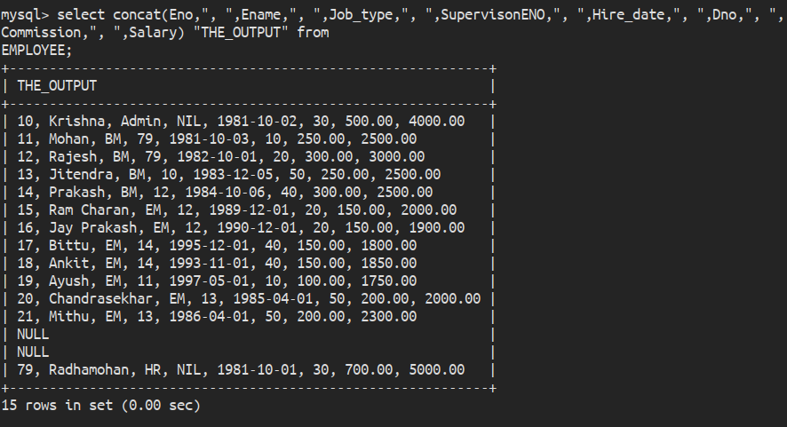**-**

**:::QUERY-5:::**

Query to display the Employee Name and Salary of all the employees earning more than $2850.

**:::RESULT:::**

select Ename "Employee Name", Salary "Salary" from EMPLOYEE where Salary > 2850;

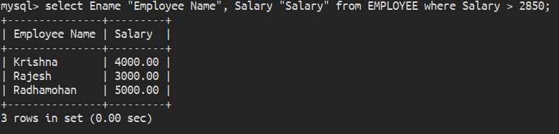

**:::QUERY-6:::**

Query to display Employee Name and Department Number for the Employee No= 79.

**:::RESULT:::**

select Ename "Employee Name", Dno "Department Number" from EMPLOYEE where Eno = 79;

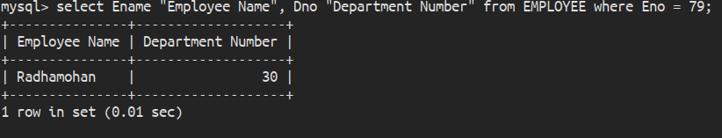

**:::QUERY-7:::**

Query to display Employee Name and Salary for all employees whose salary is not in the range of $1500 and $2850.

**:::RESULT:::**

select Ename "Employee Name", Salary "Salary" from EMPLOYEE where Salary < 1500 or Salary > 2850;

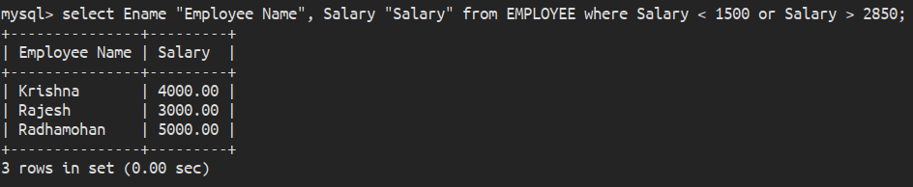

**:::QUERY-8:::**

Query to display Employee Name and Department No. of all the employees in Dept 10 and Dept 30 in the alphabetical order by name.

**:::RESULT:::**

select Ename "Employee Name", Dno "Department Number" from EMPLOYEE where Dno = 10 or Dno = 30 order by Ename;

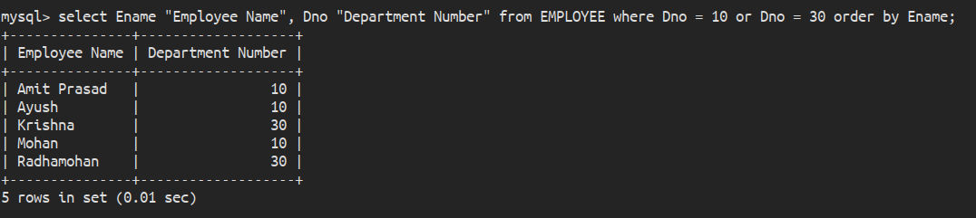

**:::QUERY-9:::**

Query to display Name and Hire Date of every Employee who was hired in 1981.

**:::RESULT:::**

select Ename , Hire_date from EMPLOYEE where Hire_date like "1981%";

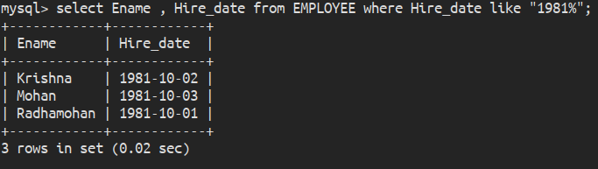**:::QUERY-10:::**

Query to display Name and Job of all employees who have not assigned a supervisor.

**:::RESULT:::**

select Ename , Job_type from EMPLOYEE where SupervisonENO = "NIL";

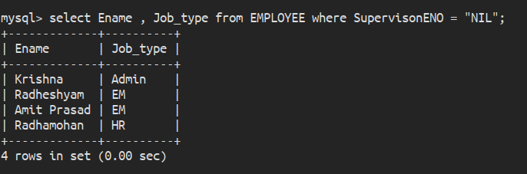

**:::QUERY-11:::**

Query to display the Name, Salary and Commission for all the employees who earn commission.

**:::RESULT:::**

select Ename , Salary , Commission from EMPLOYEE where Commission != 0;

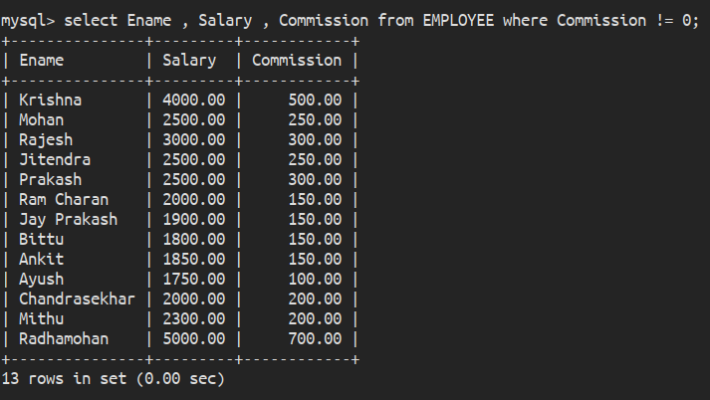

**:::QUERY-12:::**

Sort the data in descending order of Salary and Commission.

**:::RESULT:::**

select * from EMPLOYEE order by Salary desc , Commission desc;

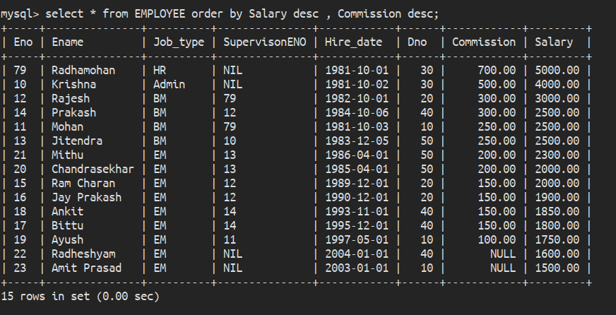

**:::QUERY-13:::**

Query to display Name of all the employees where the third letter of their name is ‘A’.

**:::RESULT:::**

select Ename "Employee Name" from EMPLOYEE where Ename like "__a%";

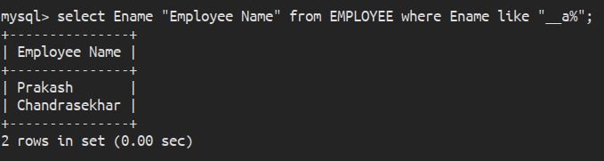

**:::QUERY-14:::**

Query to display Name of all employees either have two ‘R’s or have two ‘A’s in their name and are either in Dept No = 30 or their Manger’s Employee No = 778.

**:::RESULT:::**

select Ename "Employee Name" from EMPLOYEE where Ename like "rr%" or "aa%" or Dno = 30 or Eno = 778;

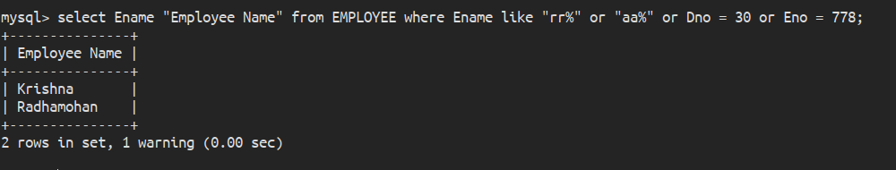

**:::QUERY-15:::**

Query to display Name, Salary and Commission for all employees whose Commission amount is greater than their Salary increased by 5%.

**:::RESULT:::**

select Ename, Salary, Commission from EMPLOYEE where Commission > (Salary + 0.05 * Salary);

**p15**

**:::QUERY-16:::**

Query to display the Current Date along with the day name.

**:::RESULT:::**

select Curdate() "Current Date" , Dayname(Curdate()) "Day";

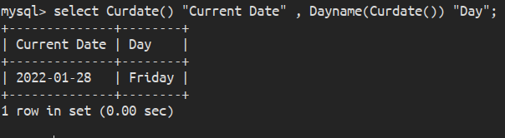

**:::QUERY-17:::**

Query to display Name, Hire Date and Salary Review Date which is the 1st Monday after six months of employment.

**:::RESULT:::**

select y.Emp_name as 'Name',

y.Hiring_date,

case

when dayname(y.new_date) = 'Tuesday' then adddate(y.new_date, interval 6 day)

when dayname(y.new_date) = 'Wednesday' then adddate(y.new_date, interval 5 day)

when dayname(y.new_date) = 'Thursday' then adddate(y.new_date, interval 4 day)

when dayname(y.new_date) = 'Friday' then adddate(y.new_date, interval 3 day)

when dayname(y.new_date) = 'Saturday' then adddate(y.new_date, interval 2 day)

when dayname(y.new_date) = 'Sunday' then adddate(y.new_date, interval 1 day)

else y.new_date

end as Salary_review_date

from (

select x.Ename Emp_Name,

x.Hire_date Hiring_date,

adddate(hire_date, interval 6 month) new_date

from (

select Ename,

Hire_date

from EMPLOYEE

) x

) y;

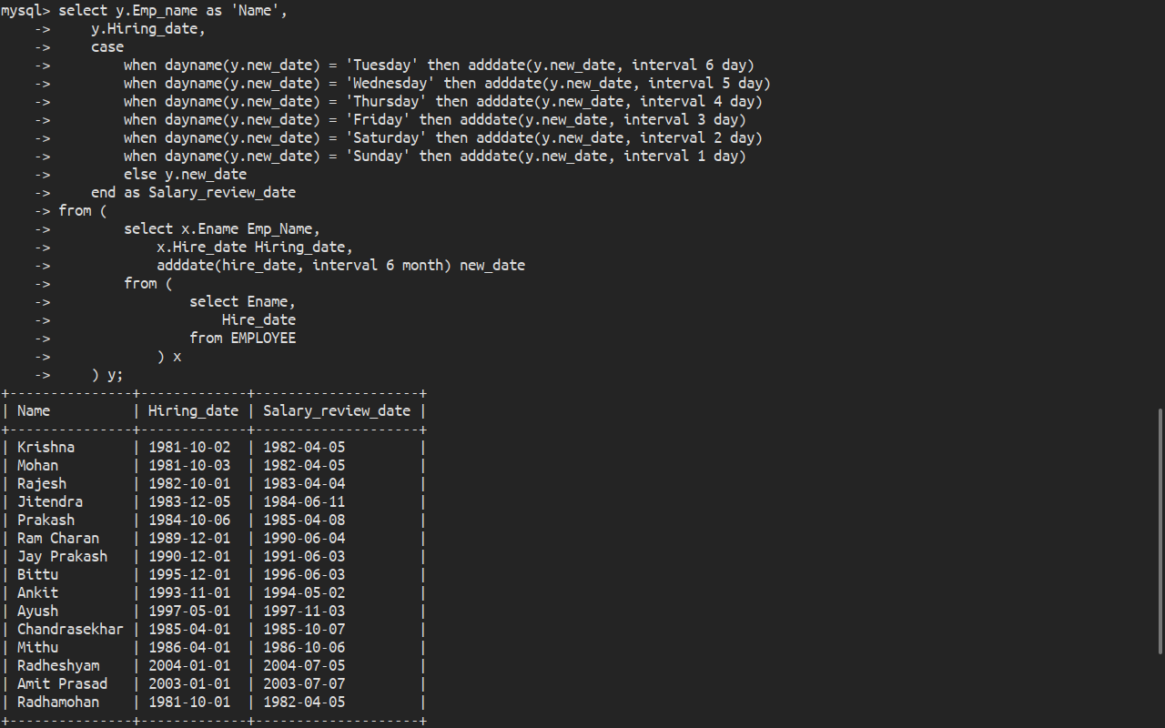

**:::QUERY-18:::**

Query to display Name and calculate the number of months between today and the date on which employee was hired of department ‘Purchase’.

**:::RESULT:::**

select Ename Name, TIMESTAMPDIFF(MONTH,Hire_date,Curdate()) "Months Between Today and Hire_date" from EMPLOYEE NATURAL JOIN DEPARTMENT where Dname = "Purchase";

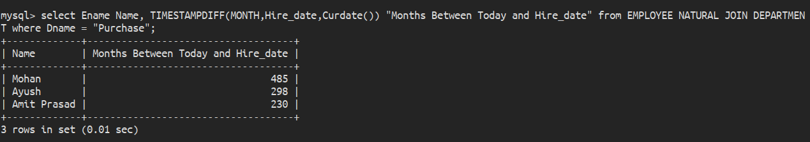

**:::QUERY-19:::**

Query to display the following for each employee <E-Name> earns < Salary> monthly but wants < 3 * Current Salary >. Label the Column as Dream Salary.

**:::RESULT:::**

select concat(Ename," earns $",Salary," monthly but wants $", 3*Salary, ".") "Dream Salary" from EMPLOYEE;

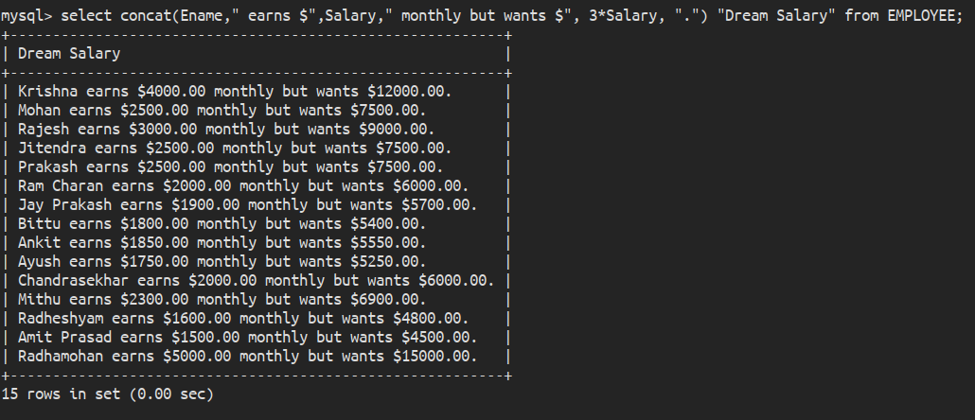

**:::QUERY-20:::**

Query to display Name with the 1st letter capitalized and all other letter lower case and length of their name of all the employees whose name starts with ‘J’, ’A’ and ‘M’.

**:::RESULT:::**

select Ename from EMPLOYEE where Ename like "J%" or "A%" or "M%";

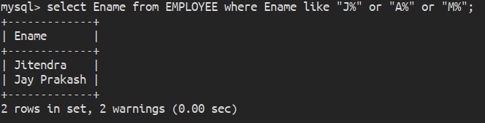

**:::QUERY-21:::**

Query to display Name, Hire Date and Day of the week on which the employee started.

**:::RESULT:::**

select Ename,Hire_date,DAYOFWEEK(Hire_date) DayOfWeeek from EMPLOYEE;

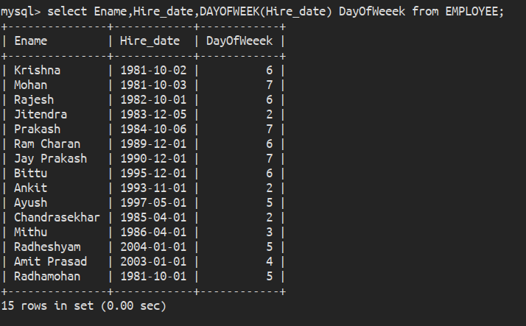

**:::QUERY-22:::**

Query to display Name, Department Name and Department No for all the employees.

**:::RESULT:::**

select EMPLOYEE.Ename Name, EMPLOYEE.Dno "Department Number" ,DEPARTMENT.Dname "Department Name" from EMPLOYEE.EMPLOYEE NATURAL JOIN EMPLOYEE.DEPARTMENT;

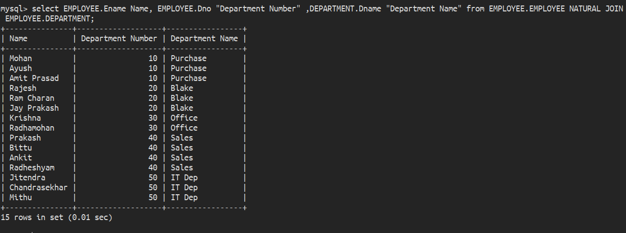

**:::QUERY-23:::**

Query to display Unique Listing of all Jobs that are in Department number 30.

**:::RESULT:::**

**`**

select Job_type from EMPLOYEE NATURAL JOIN DEPARTMENT where Dno = 30;

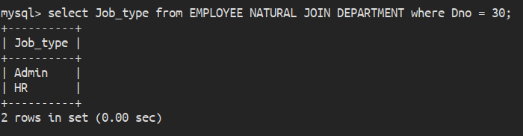

**:::QUERY-24:::**

Query to display Name, Dept Name of all employees who have an ‘A’ in their name.

**:::RESULT:::**

select Ename Name,Dname "Department Name" from EMPLOYEE NATURAL JOIN DEPARTMENT where Ename like "%A%";

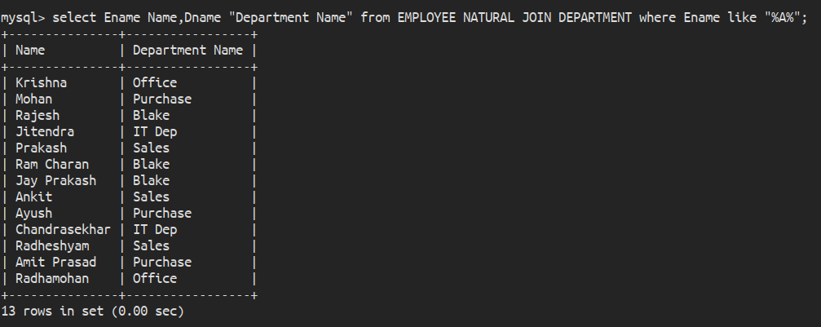

**:::QUERY-25:::**

Query to display Name, Job, Department No. And Department Name for all the employees working at the Dallas location.

**:::RESULT:::**

select Ename Name,Job_type Job, Dno "Department Number", Dname "Department Name" from EMPLOYEE NATURAL JOIN DEPARTMENT where Location = "Dallas";

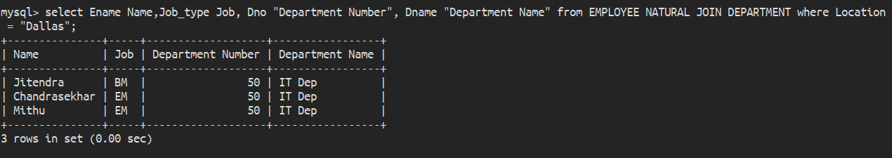

**:::QUERY-26:::**

**:::RESULT:::**

**:::QUERY-27:::**

**:::RESULT:::**

**:::QUERY-28:::**

**:::RESULT:::**

**:::QUERY-29:::**

**:::RESULT:::**

**:::QUERY-30:::**

**:::RESULT:::**

**:::QUERY-31:::**

**:::RESULT:::**

**:::QUERY-32:::**

**:::RESULT:::**

**:::QUERY-33:::**

**:::RESULT:::**

**:::QUERY-34:::**

**:::RESULT:::**

**:::QUERY-35:::**

**:::RESULT:::**

**:::QUERY-36:::**

**:::RESULT:::**

**:::QUERY-37:::**

**:::RESULT:::**

**:::QUERY-38:::**

**:::RESULT:::**

**:::QUERY-39:::**

**:::RESULT:::**

**:::QUERY-40:::**

**:::RESULT:::**

**:::QUERY-41:::**

**:::RESULT:::**

**:::QUERY-42:::**

**:::RESULT:::**